FAKE

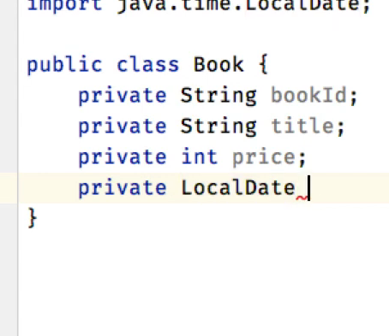

Test acse

**DUMMY**

We will be using the above classes only

Book,bookrepo,bookservice

But now we have a new dependency of email but we don’t want to use it so we will make a dummy of it

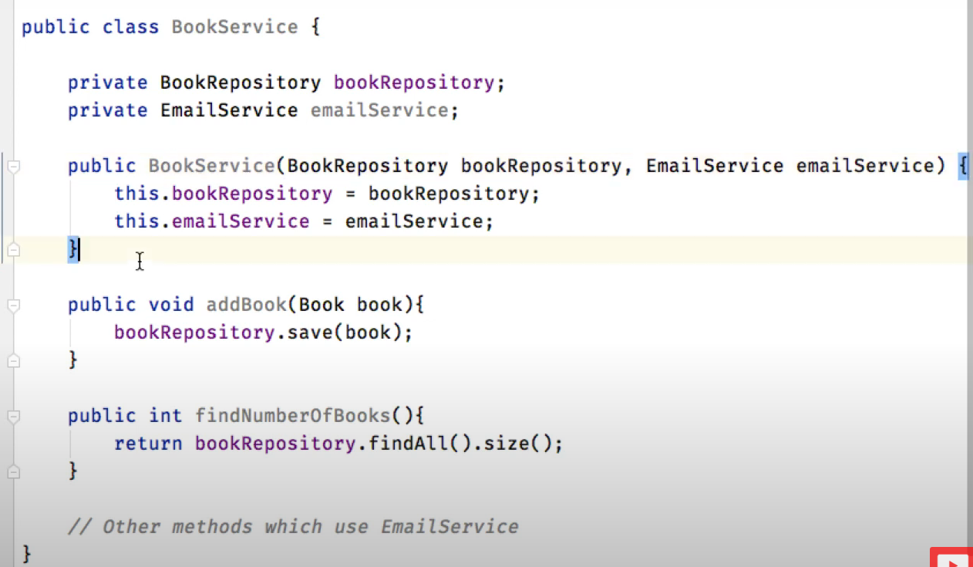

**STUB**

